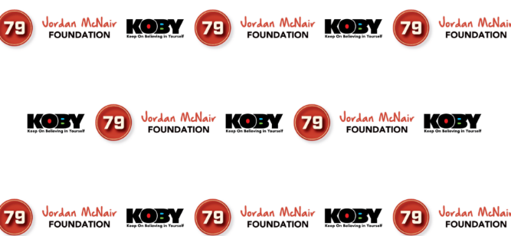
K.O.B.Y. Coach of the Year Nomination Form
(AAU through High School)
KOBY stands for Keep On Believing In Yourself. It is a set of guiding principles that promote Courage, Confidence and Self Advocacy among student athletes.
Do you know of a coach who encourages and inspires their players to not only succeed in the game, but also in the classroom and in life? Someone who makes certain the team enjoys playing in a nurturing environment and is safe while doing so by making sure venue specific emergency action plans are in place and rehearsed? Making certain that all emergency equipment is available, and all coaches are CPR and First Aid certified? One who goes above and beyond to support their players’ goals, aspirations, and dreams? If so, please submit their name to be a nominee for the first annual K.O.B.Y. Coach of the Year Award recipient.
***************************************************************
Nominee Name: Cell Number w/area code:
Coach Name: Contact # w/area code:
Team name: Sport:

Please provide a brief 5 to 6 sentence description of why they should be considered a finalist for the award.

All entries must be submitted by email to tjmf7079@gmail.com by Wednesday March 15th for final consideration. The name of the winning recipient will be announced on Wednesday March 29th at 6:00p.m. For questions, please contact David Johnson at dannyj7719@gmail.com or Patrice Miles at pvmiles@gmail.com.

The Jordan McNair Foundation | P.O. Box 11077 | Baltimore, MD 21212| www.tjmf79.org 