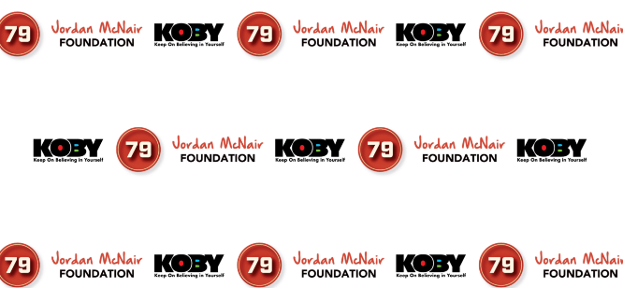
KOBY Student Athlete of the Year Award Nomination Form
(AAU through High School)
KOBY stands for Keep On Believing In Yourself. It is a set of guiding principles that promote Courage, Confidence and Self Advocacy among student athletes.
Do you know of a student athlete who displays exemplary character on the field of play and in the classroom? Someone who demonstrates a strong belief in themselves. One who encourages their fellow teammates and looks out for their wellbeing? If so, please submit their name to be a nominee for the first annual K.O.B.Y. Student Athlete of the Year Award recipient.
*****************************************************************
Student Athlete Name:
Age: Grade: Sport(s):
Nominee Name: Cell # w/area code:
Please provide a 5 to 6 sentence description of why they should be considered a finalist for the award.

All entries must be submitted to email address: tjmf7079@gmail.com by Wednesday March 15th for final consideration. The name of the winning recipient will be announced on Wednesday March 29th at 6:00p.m. For questions, please contact David Johnson at dannyj7719@gmail.com or Patrice Miles at pvmiles@gmail.com.
The Jordan McNair Foundation | P.O. Box 11077 | Baltimore, MD 21212| www.tjmf79.org 